Activity 1
Define what an algorithm is and outline the characteristics of a good algorithm. Write the algorithms to display the Fibonacci series and the factorial value for a given number using Pseudo code. Determine the steps involved in the process of writing and executing a program and carry out an analysis of writing the code phase by discussing the potential challenges faced.

Explain what is an algorithm with examples. (P1)
Define characteristics of a good algorithm. (P1)
Need to write pseudocode to display Fibonacci series. (P1)
Need to write pseudocode to display factorial value of a given number. (P1)
Mention and explain the steps involved in developing a program. (P2)
Explain in detail what is coding phase, what a programmer should do in coding phase and challenges you face during this stage and how to overcome these challenges. (M1)

Take a sample number and dry run the above two algorithms. Show the outputs at the end of each iteration and the final output. Examine what Big-O notation is and explain its role in evaluating efficiencies of algorithms. Write the Python program code for the above two algorithms and critically evaluate their efficiencies using Big-O notation.

Dry run Fibonacci series (P1)
Dry run factorial pseudocode. (P1)
Show the outputs at the end of each iteration and the final output (P1)
Explain what is big o’ notation. (D1)
Write the importance and role of Big -o notation. (D1)
Convert two pseudocodes to python. (D1)
Evaluate the efficiency of these two programs using Big-O notation. (D1)
Compare find the relationship between the written algorithm and python code of Factorial and Fibonacci. (D1)

Activity 2

Compare and discuss what is meant by a Programming Paradigm and the main characteristics of Procedural, Object oriented and Event-driven paradigms and the relationships among them. Write small snippets of code as example for the above three programming paradigms using a suitable programming language(s) and critically evaluate the code samples that you have given above in relation to their structure and the unique characteristics.

Explain what is programming paradigm giving examples. (P3)

Explain main programming paradigms (procedural, object-oriented and event-driven) (P3)
- Small introduction
- Characteristics/features
- Advantages/ disadvantages
- Relationship between other programming paradigms
Compare the relation between these programming paradigms mentioning similarities and dissimilarities. (M2)
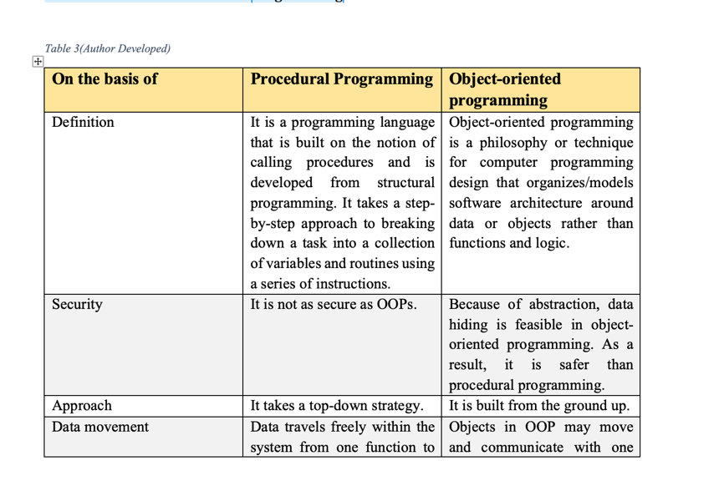

Provide small code sample for each programming paradigm with screen shots of the outputs. (P3)

Critically evaluate these code samples in terms of the code structure and characteristics by comparing with other programming paradigms. (D2)

Activity 3

- Write the complete pseudocode to calculate the cost of training fees for KickBlast athletes for each month. Use the visual studio IDE (using C#.net) to implement the above algorithms. The developer can decide the methods which need to be included when developing the classes. Design the suitable database structure for keeping the data of the above system.

Write the pseudocode to calculate the cost of training fees (P4)
Provide the implemented code for the above pseudocode (C#) (P4)
Provide screen shots of the developed database tables. (P4)

Analyze the features of an Integrated Development Environment (IDE) and explain how those features help in application development. Evaluate the use of the Visual StudioIDE for your application development contrasted with not using an IDE.
Explain what is an IDE. (M3)
Explain main component of an IDE and mention how these components help in application development. (M3)
Explain Visual Studio IDE and its features.(M3)
Evaluate the development process with using and without using an IDE. (D3)

Activity 4

  - Design and build a small GUI system for the above scenario and it should be a complete functional system with all the functions which has described in the above scenario with the database structure which has designed in activity 3.
Provide entire source code with GUIs and database implementation. (P4)

  - Examine debugging process and the features available in Visual studio IDE for debugging your code more easily. Evaluate how you used the debugging process to develop more secure, robust application with examples.
Explain what is debugging. (P5)
Explain the importance of debugging. (P5)
Features available in Visual studio for debugging. (P5)
Evaluate how you can develop secure and robust application with the use of debugging features in Visual studio IDE. (M4)
Sample answer
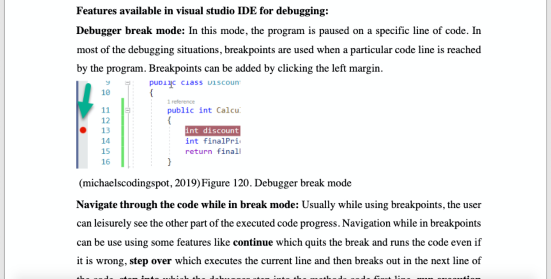

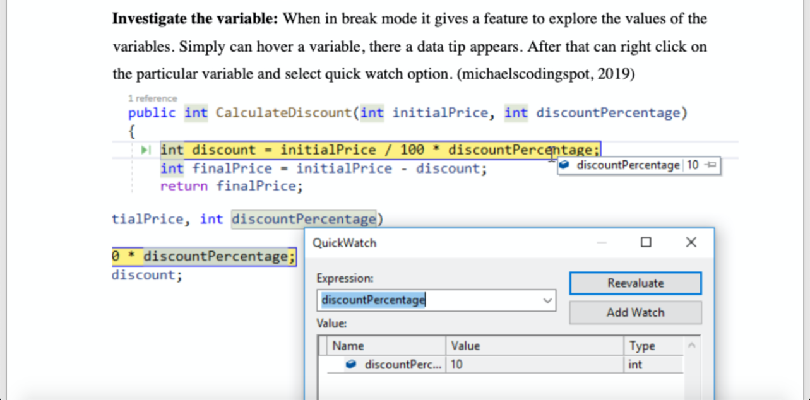

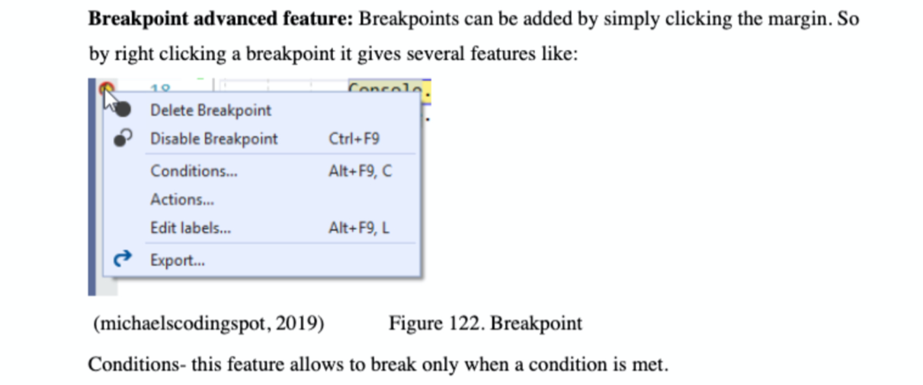

  - Explain and outline the coding standards you have used in your application development. Critically evaluate why a coding standard is necessary for the team as well as for the individual.
Explain what is coding standards. (P6)
Why coding standards are important (P6)
Explain few most common coding standards. (P6)
Provide coding standards with proper explanations and evidences used for developed application. (P6)
Critically evaluate why coding standards are important for a team as well as individual developer. (D4)

